Template for the Growth-share matrix
Also known as B.C.G. analysis, BCG-matrix, Boston Box, Boston Matrix, Boston Consulting Group analysis, portfolio diagram
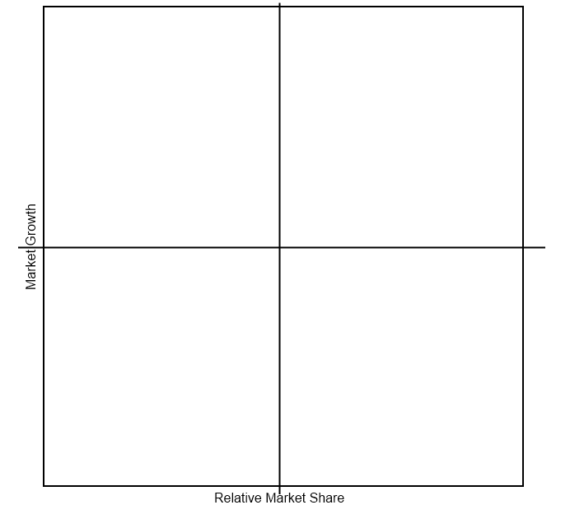


Symbols


